BOOKS FOR AFRICA RECEIVAL AND DISTRIBUTION, ZIMBABWE
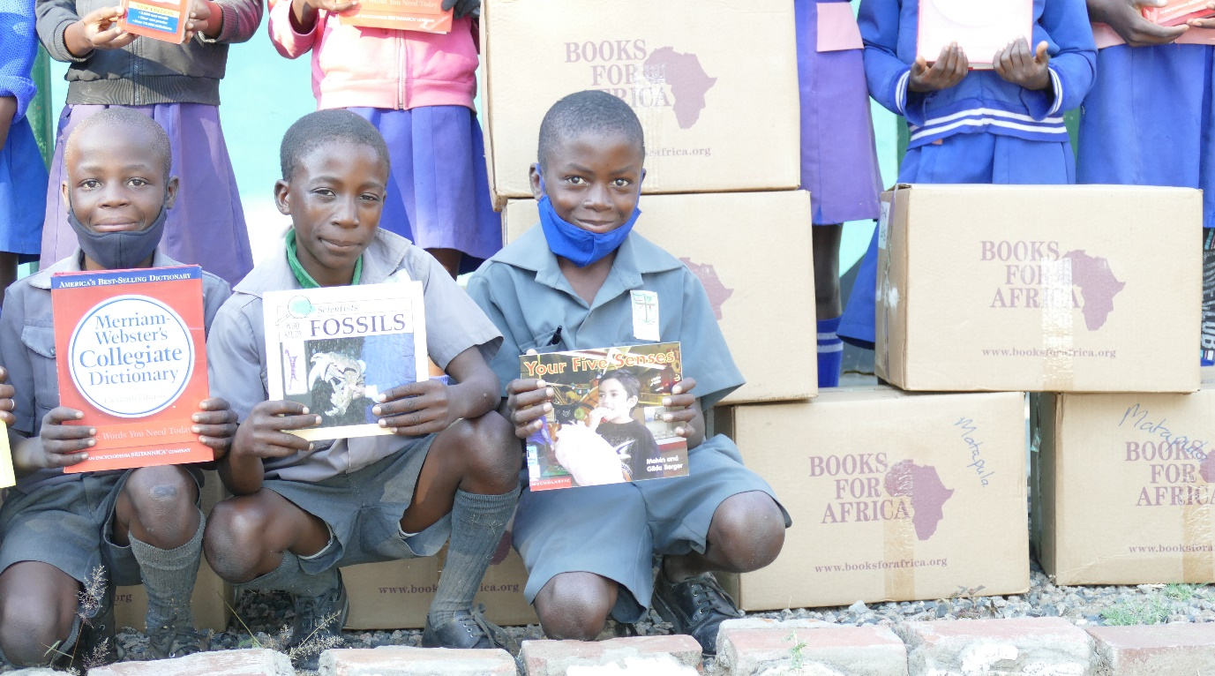
Thanks to Books for Africa, we have started distributing a wide range of books to rural schools in Zimbabwe. Over two shipments: one in late 2020 and one in 2021, 35 pallets (over 1000 boxes of books) were designated to CITW. Due to the sheer volume of books and schools being closed until March this year, we had the boxes stored for us in Harare and have been bringing them to Victoria Falls bit by bit. We now have both shipments in our warehouse; the boxes have been sorted, and so far 230 boxes have been distributed or collected by other organisations around Victoria Falls so that the reach around this region can be as wide as possible.
On a trip to the Tsholotsho region south of Hwange National Park in May, we were able to deliver books to two schools that we have partnered with more recently: Mlevu and Mtshayeli Primaries. Unlike the other schools that we work with in this remote region, these schools are far from others in the cluster and have never received Books for Africa books before. Teachers and students were incredibly excited and grateful for this delivery, and we look forward to taking them more as soon as we can.
With schools back in a temporary shutdown due to Covid-19, our distributions have had to be put on hold. However, we are ready and rearing to complete these for other schools in Victoria Falls, Hwange, Tsholotsho, and Beit Bridge as soon as they open again!
With so many lasting benefits, we would like to once again give thanks to Books for Africa for their ongoing support over the years. It is very much appreciated, and by passing on these resources to schools, children for years to come are given the valuable gift of literary resources – opening their minds to thousands of new worlds.

