EKTTS/BFA

January 1, 2020-January 17, 2020(Addis Ababa and Ambo) and
January 26, 2020 – February 18, 2020 (Wolkite, Alaba Kulito and Worabe)

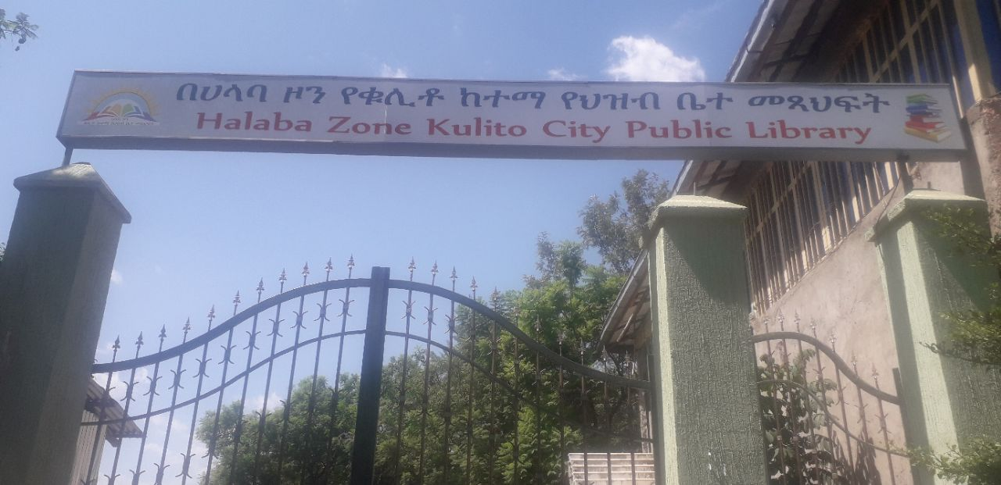

By: Habtamu Mechemeria (Training officer)
Contents
Introduction 2
Objective of the Trip 2
Major Activities of the Trip 2
Reader mobilization, promote the availability of low priced valuable books and conversation with higher officials. 5
Limitation Identified after Making the Assessment 7
Recommended Solutions 8
Trainees and concerned bodies photo 9

Introduction
As in the case of most developing countries in Africa readership among primary and secondary students is low in most rural parts of Ethiopia. Even after several years in school, thousands of rural students in Ethiopia are facing difficulties to comprehend concepts of their study. This is mainly because of their poor readership habits.
The Pilot Librarian and Outreach Program that is under implementation through the collaboration of Ethiopian Knowledge and Technology Transfer Society and Book For Africa is exerting its positive influence on the library service and readership habits of the community where EKTTS and BFA are intervening. As part of this partnership, thousands of public library users oriented about the importance of reading habits, around 301 librarians took library science training and 21 public libraries improved their service to users.
EKTTS prepared and conducted the Seventh round reader’s mobilization and empowering librarian trip to the north Southern part of Ethiopia from the January 26, 2020 – February 18, 2020 targeting public libraries at Addis Ababa ,Ambo Wolkite, Alaba Kulito and Worabe and also from January 1 ,2020-January 17, 2020 Addis Ababa and Ambo towns.

Objective of the Trip
The main objective of the trip is to examine the importance of Books donated by BFA and increase the readership habits of library users at Addis Ababa, Ambo , Wolkite, Alaba Kulito and Worabe through reader mobilization activities and capacitating training.

Major Activities of the Trip
- Comprehend the Reading Habit of the Community
- Facilitate the Establishment of Book Readers’ Clubs
- Promote the Availability of Low Priced Valuable Books
- Advocate the Need to Establish Public Libraries

EKTTS training back trip report Detail Table
Location and Tr.period | No. of trainees | Major Training offered | Outcome of the training
Wolkite(Southern Ethiopia)  From January 26,2020 -February 1,2020 | 20 | -Cataloguing and Classification skill has been offered.  -Customer handling and satisfaction  -Registration of basic bibliographic elements on a computer also has been briefed and  -Managing shelf location and shelf Reading has been offered  -Creating library database and how to manage library resource using computer  -Circulation and handling user statistics | -The trainees can classify and catalogue classify library materials with practice  -They can create library database and know about library automation  -they offer how can attract and maximize library users and improve reading habit
Halaba Kulito (Southern Ethiopia)  From February 3, 2020-February 8, 2020 | 25 | -Cataloguing and Classification skill has been offered.  -Customer handling and satisfaction  -Registration of basic bibliographic elements on a computer also has been briefed and  -Managing shelf location and shelf Reading has been offered  -Creating library database and how to manage library resource using computer  -Circulation and handling user statistics | The trainees can classify and catalogue classify library materials with practice  -They can create library database and know about library automation  -they offer how can attract and maximize library users and improve reading habit
Worabe (Southern Ethiopia)  From February 10,2020-February 15,2020 | 5 | -Cataloguing and Classification skill has been offered.  -Customer handling and satisfaction  -Registration of basic bibliographic elements on a computer also has been briefed and  -Managing shelf location and shelf Reading has been offered  -Creating library database and how to manage library resource using computer  -Circulation and handling user statistics | The trainee can classify and catalogue library materials with practice  -They can create library database and know about library automation  -they offer how can attract and maximize library users and improve reading habit
Addis Ababa  (Central Ethiopia)  From January 1,2020-10,2020 | 15 | Cataloguing and Classification skill has been offered.  -Customer handling and satisfaction  -Registration of basic bibliographic elements on a computer also has been briefed and  -Managing shelf location and shelf Reading has been offered  -have been offered Koha system(catalogue, patron, Report, Circulation module)  -koha customization after installation | -managing koha records (add record, delete record, edit record and modify record )  The trainee can classify and catalogue library materials with practice  -They can create library database and know about library automation  -they offer how can attract and maximize library users and improve reading habit
Ambo(central )  From January 12, 2020-17, 2020 | 17 | Cataloguing and Classification skill has been offered.  -Customer handling and satisfaction  -Registration of basic bibliographic elements on a computer also has been briefed and  -Managing shelf location and shelf Reading has been offered  -Creating library database and how to manage library resource using computer  -Circulation and handling user statistics | The trainee can classify and catalogue library materials with practice  -They can create library database and know about library automation  -they offer how can attract and maximize library users and improve reading habit

Reader mobilization, promote the availability of low priced valuable books and conversation with higher officials.
Location | Reader mobilization | Promoting low priced valuable book | Conversation with higher officials
Wolkite | -There is no Reading club before EKTTS trainer visit school library  - EKTTS trainer establishes reading club in primary and junior school | -EKTTS trainer meet Wolkite University Academic vice president about BFA and the availability of low priced valuable books.  -and also meet Ambo University Library Director about the process and how they get. | -EKTTS Trainer meet with Wolkite Culture And tourism higher officials and have fruit full discussion about all the problem identified like shortage of library Furniture, lack of trained manpower and the establishments of new library.
Alaba kulito | -There is two reading club in Alaba Kulito high school And primary school  - EKTTS trainer gives advice and strengthen the existing club  -the existing club practiced in a good way | -In the case of Alaba Kulito, there is no Governmental university so, EKTTS trainer try to meet with Private college and Universities exist in the city. | -EKTTS Trainer meet with Alaba Kulito Culture And tourism higher officials and have fruit full discussion about all the problem identified like shortage of library Furniture, lack of trained manpower and the establishments of new library.
Worabe | There is one reading club in Worabe high school  - EKTTS trainer establishes another reading club in Worabe primary and Secondary school  -the existing club practiced in a good way | EKTTS trainer meet Worabe University Academic vice president about BFA and the availability of low priced valuable books.  -and also meet Ambo University Library Director about the process and how they get. | -EKTTS Trainer meet with Worabe Culture And tourism higher officials and have fruit full discussion about all the problem identified like shortage of library Furniture, lack of trained manpower and the establishments of new library.
Addis Ababa | There is 10 reading club in Addis Ababa high school  - EKTTS trainer Strengthen the existed Reading club  -the existing club practiced in a good way | EKTTS trainer meet Addis Ababa University Academic vice president about BFA and the availability of low priced valuable books.  -and also meet Addis Ababa University Library Director about the process and how they get. | -EKTTS Trainer meet with Addis Ababa Culture And tourism higher officials and have fruit full discussion about all the problem identified like shortage of library Furniture, lack of trained manpower and the establishments of new library.
Ambo | There is one reading club in Ambo high school  - EKTTS trainer establishes another reading club in Ambo primary and Secondary school  -the existing club practiced in a week way | EKTTS trainer meet Ambo University Academic vice president about BFA and the availability of low priced valuable books.  -and also meet Ambo University Library Director about the process and how they get. | -EKTTS Trainer meet with Ambo Culture And tourism higher officials and have fruit full discussion about all the problem identified like shortage of library Furniture, lack of trained manpower and the establishments of new library.

Limitation Identified after Making the Assessment

- Luck of commitment to coordination and effort among concerned line offices to help the community increase their reading culture.
- Shortage of Library furniture such as standard shelf, Circulation desk, and new arrival display board etc.
- The section of library not implemented in all Public Library. For example, binding section, Reference section, children’s section and periodical section etc.
- Clarity problem about understanding the positive impacts of having Book Clubs inside the primary and secondary schools.
- When conducting the reader’s mobilization trips including the first two public libraries of Eastern Ethiopia, EKTTS witnessed shortages of basic books and the need of procuring additional reference materials.
- High demand to establish additional public libraries in and around the town to meet the demand of increasing library users.
- Books have not been scientifically organized therefore there is no way for users to know whether any book they need is available or not in the library’s holdings.
- The recruitment of library staff is other than Library and information science
- There is no planned library promotion policy and service, such as, reading and literacy campaign, annual library week celebrations public speaking activities and so forth

Recommended Solutions
After deep assessment and observation, EKTTS trainer and concerned stakeholders from culture and tourism and education offices recommended the need of incorporating the below mentioned activities to increase the reading habit of their local community:
- Introducing new library management system which helps to create easy access to the librarian and users as well as provide training.
- Attract residents by launch book exhibitions and reading day.
- Establish good communication with youth and women associations to work together in the enhancement of public libraries.
- To use social media, monthly or quarterly bulletins of the office to promote the reading culture of the community and services given by the public libraries in these towns.
- Organize ceremonies like reading day, lecture hours, and so on.
- Make reward and recognition for those public library users who frequently make a visit
- Promote by using different media such as community radio program, pamphlets, brochures and flyers to introduce the library and its services
- Establish library web-site and online service to increase accessibility of library service and create awareness about new arrivals
- Establish and organizing children’s room at Worabe and Alaba kulito public library
- Establish reader’s advisory services in the library to assist users in their information need.
- Make user need assessment 4 times per year to satisfy and attract users.
- Purchase different library material and furniture

Trainees and concerned bodies photo
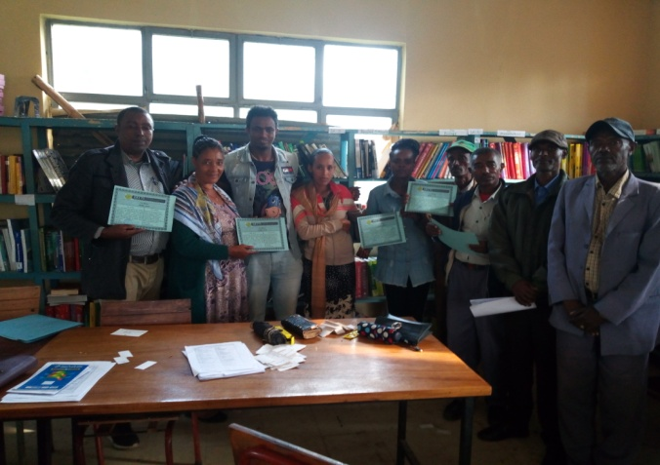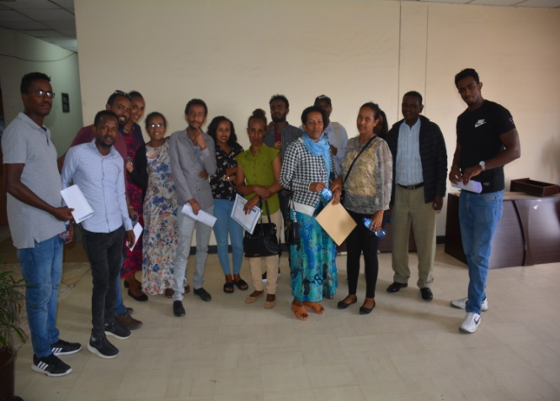
Ambo trainee after Certification Addis Ababa Special Library trainee sample pic.
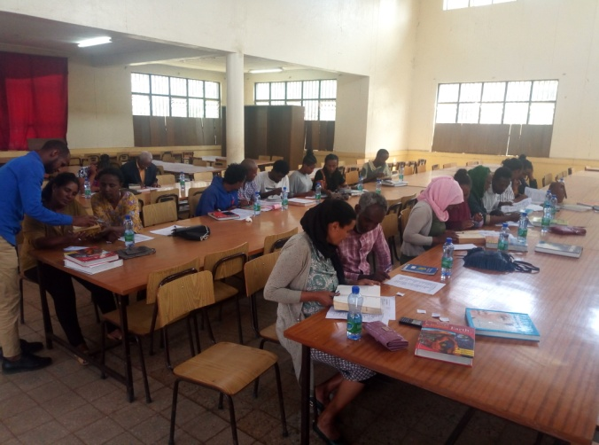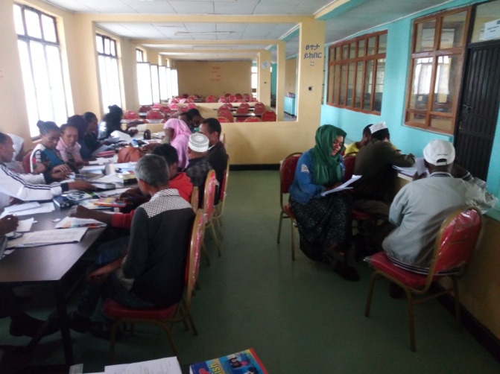
Wolkites trainee sample Alaba kulitos Trainee
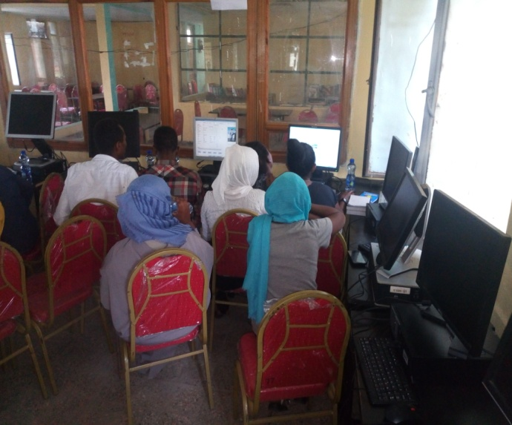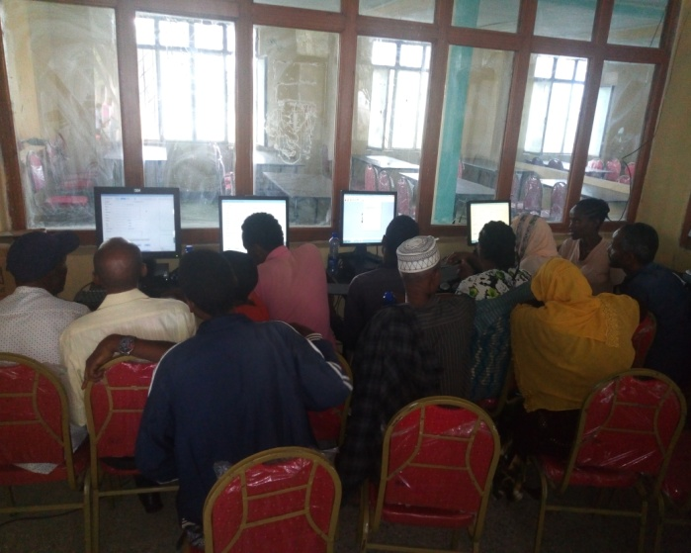
Alaba Kulito Trainee Computer lab During Practical Exercise about Library Automation

